Science and Technology Committee

Topic: The use of hypersonic weapons: is it really necessary? If so, how should the defense system be?

Introduction of the Committee:

From its origins in 1955, the Assembly recognised the central role of science and technology in maintaining both the security and prosperity of the nations of the Euro-Atlantic Community. It considers both the challenges arising from science and technology, and the opportunities that science and technology offer to address the defence and security challenges faced by the Euro‑Atlantic area and beyond. The areas covered by the Science and Technology Committee include: Science and technology policies and activities of military and civil importance to the Euro‑Atlantic community; The security challenges posed by the proliferation of chemical, biological, radiological, and nuclear material, technologies and expertise, as well as their methods of delivery, and the non-proliferation measures to address these challenges; etc.

Introduction of the Topic:

There are two types of hypersonic weapons: hypersonic glide vehicles (HGV) and hypersonic cruise missiles (HCM). Hypersonic weapons fly at speeds of Mach 5 or above and combine the high manoeuvrability and accuracy of a cruise missile with the speed of a ballistic missile. They are significantly harder to track than ICBMs. Moreover, according to Michael Griffin, former Undersecretary of Defense for Research and Development at the US Department of Defense, “Hypersonic targets are 10 to 20 times dimmer than what the United States normally tracks by satellites in geostationary orbit.” Funding for hypersonic programmes has significantly increased in many countries, including Russia, the PRC, and recently, the United States.

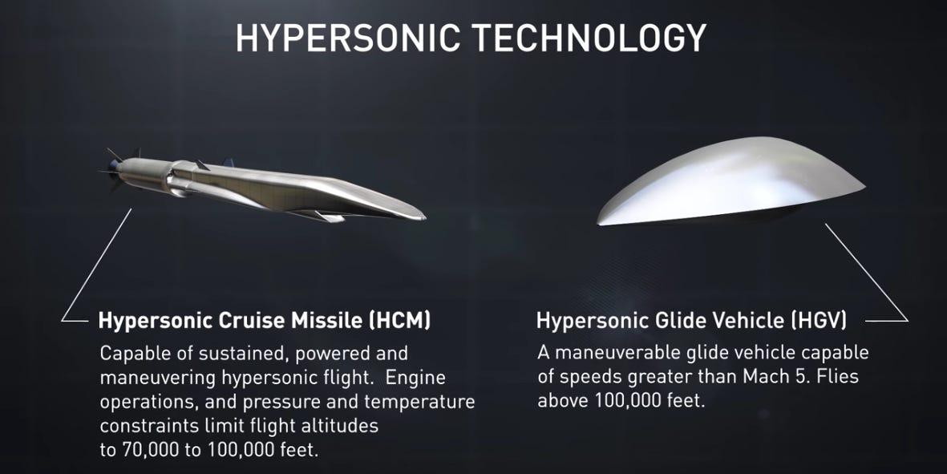
https://www.youtube.com/watch?v=FyUTNRIuAqc

History of the Topic:

Hypersonic flight is not new, a large number of projects have been conducted in the past, including for example the American X-15 aircraft in the 1960s, or the development of ballistic missiles. The increased attention to hypersonic flight is due to the technological progress made which now allows controlled hypersonic flight, including in the atmosphere. Addressing the issue of hypersonic weapons has taken on a sense of urgency. Russia and the People’s Republic of China (PRC) appear to be moving from research and development to deployment more quickly than the United States and other Allies of this new class of weapon system which some consider to be a game changer.

The Current Situation:

Currently deployed ballistic missile defence interceptor systems are not designed to operate at altitudes of the flight paths of hypersonic weapons. The interceptors of the ship-based US Aegis and the ground-based Terminal High-Altitude Area Defense (THAAD) anti-missile systems operate in the near vacuum of space but do not perform well in the thin upper atmosphere. Ground-based air defence systems, such as the US Patriot, are designed to intercept missiles with a lower flight path than hypersonic weapons. NATO’s ballistic missile defence system, which is built around the US’ European Phased Adaptive Approach (EPAA) and Aegis Ashore, is also neither designed to, nor capable of, intercepting hypersonic missiles. The development of hypersonic technology therefore requires considerable resources and time.

Definition of Key Terms:
Hypersonic: Hypersonic speeds are typically speeds that are at least five times greater than the speed of sound, or Mach 5.
Dimmer: Heat signatures emitted by hypersonic missiles are generally weaker than those of ballistic missiles and therefore less visible, they appear dimmer, on a radar screen.

ICBM: An intercontinental ballistic missile (ICBM) is a missile with a minimum range of 5,500 kilometres primarily designed for nuclear weapons delivery.

Mach: A measurement of speed that is calculated by dividing the speed of an object, especially an aircraft, by the speed of sound.
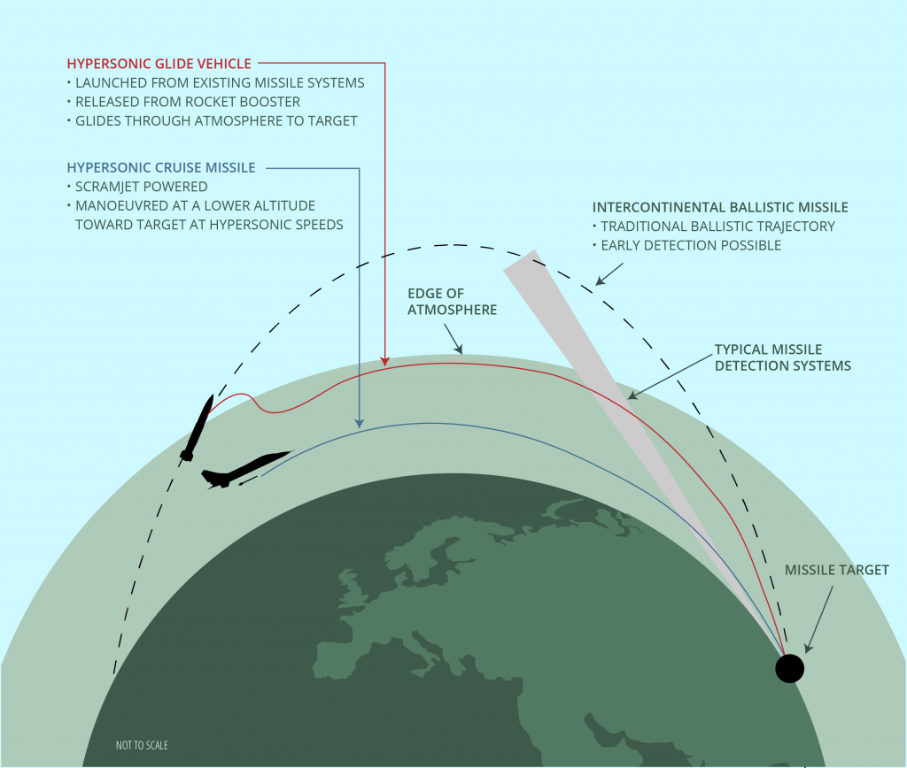
https://ploughshares.ca/pl_publications/the-risks-of-hypersonic-weapons/

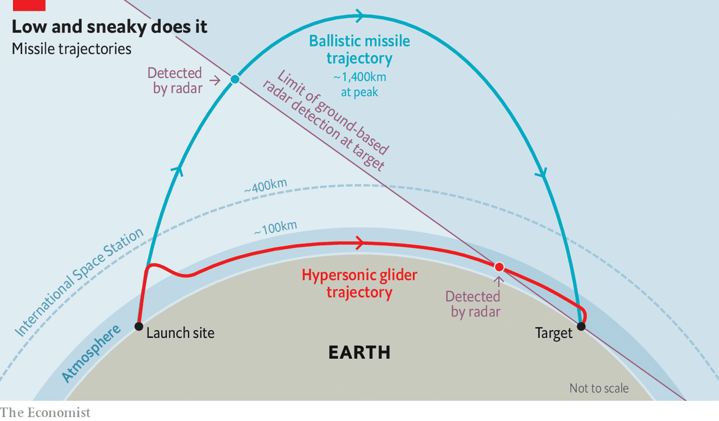https://www.economist.com/science-and-technology/2019/04/06/gliding-missiles-that-fly-faster-than-mach-5-are-coming

Russia:

Russia has been conducting research on hypersonic technology since the 1980s; it accelerated its efforts after the United States’ withdrawal from the Anti-Ballistic Missile (ABM) Treaty in 2002. Russia is currently pursuing several hypersonic weapons programmes: Avangard is a hypersonic glide vehicle capable of carrying a nuclear warhead of up to two megatons. Is reported to reach a speed of Mach 20 or higher and can hit targets as much as 6,000 km away. Secondly, the 3M22 Tsirkon is a ship-launched HCM capable of travelling between Mach 6 and Mach 8. It is capable of hitting both ground and naval targets up to a distance of 1,000 km. Russia is also investing heavily in the development of new materials for hypersonic flight. According to the Russian news agency, Sputnik International, more than 40 state laboratories are doing research to find solutions to materials, communication, and propulsion systems faced in hypersonic flight. Additionally, Russia is also working on the development of a system to defend against hypersonic missiles. A 15 May report of the Russian news agency TASS quoted President Vladimir Putin as saying, “Russia should develop systems against hypersonic weapons before such weapons are developed in other countries”.

In Russia, hypersonic rivalry feeds suspicions and arrests:

As the hypersonic arms race escalates, international collaborations are crumbling—sometimes with dire consequences for researchers. Almost 10 years ago, Russian aerospace engineer Victor Kudryavtsev collaborated with Europe on Transhyberian, a €565,000 hypersonic project funded largely by the European Union. But in the summer of 2018, Russia’s Federal Security Service (FSB) arrested him and, several months later, a colleague, physicist Roman Kovalev. Both have been charged with high treason for allegedly leaking hypersonic secrets to “a NATO research center.” If found guilty, they each face up to 20 years in prison.

The charges dismay observers, who point out that a military review panel had approved the release of Russia’s contribution to Transhyberian. (The project’s coordinating institution, the von Karman Institute for Fluid Dynamics in Belgium, is affiliated with NATO but does no classified research.) FSB’s decision to classify the work came 5 years after the EU project ended. The “absolutely illicit retroactive approach … increases the vulnerability” of Russian scientists working in areas that might have military or other sensitive applications, says Boris Altshuler, a theoretical physicist and human rights activist at the Russian Academy of Sciences’s P.N. Lebedev Physical Institute.

Launched in June 2011, the 2-year project examined a phenomenon that bedevils spacecraft re-entering Earth’s atmosphere. At hypersonic speeds, laminar air flow over a surface can suddenly turn turbulent, creating intense temperature spikes on the vehicle’s surface. To study those heat fluctuations, the Transhyberian team performed wind tunnel experiments and computer simulations at the Belgian institute, the German Aerospace Center, and three Russian institutions—including the Central Research Institute of Machine Building, or TsNIIMash, a spacecraft and missile design center in Korolyov where both arrested scientists work. The research showed that locally heating or cooling the surface could help control the temperature spikes—a finding that could improve the design of hypersonic aircraft.

As project coordinator for TsNIIMash, Kudryavtsev transmitted research findings to the foreign partners. The reports were approved by the military’s Federal Service for Technical and Export Control, says Kudryavtsev’s attorney, Ivan Pavlov, a prominent human rights lawyer. Herman Deconinck, who handles the von Karman Institute’s foreign relations, notes that all references in the Russian reports had been published in the open literature.

The project aimed to strengthen collaboration between Russia and the European Union in hypersonics, Deconinck says. But the amity faded in 2014 after Europe condemned Russia’s invasion of Crimea. Relations cooled further in 2018, when Western analysts greeted Russian claims about the country’s hypersonic weapons skeptically, citing test failures. Russia then classified much of its hypersonic research, and Kudryavtsev was hauled off to Moscow’s Lefortovo Prison.

In November 2018, he was denied prison visits after rejecting a plea bargain requiring him to admit guilt and “frame a colleague,” Pavlov says. The European Court of Human Rights weighed in in April 2019, ordering Russia to provide medical treatment for Kudryavtsev, who is 76 and ailing. He was released from prison on 27 September 2019 after being diagnosed with metastatic lung cancer, says his son, Yaroslav Kudryavtsev, a polymer scientist. “They just put him outside with all his things.” Victor Kudryavtsev was told not to leave the Moscow region before his trial.

“Mentally Victor is strong, not cooperating with the investigators,” his son says. After failing to squeeze a confession out of Victor Kudryavtsev, FSB arrested Kovalev in June. He has also reportedly refused to plead guilty or incriminate colleagues and is confined in Lefortovo. In July 2019, the security service arrested a third TsNIIMash scientist, Sergey Meshcheryakov, who had participated in a different international project. He, too, is accused of high treason and is under home detention after suffering a heart attack following his arrest. Authorities have not signaled when the three researchers will face trial.

Voices outside Russia need to speak up, Altshuler says. “Strong reaction in the West is an effective practical instrument to raise the level of decision-making on the case,” he says. The Committee of Concerned Scientists, a human rights nonprofit, has worked to draw attention to the scientists’ plight. And on 29 October 2019, the von Karman Institute declared it “could not find any trace of disclosing secret information” by Kudryavtsev’s team. It asked the European Commission to pursue the matter with Russia.

The support is welcome, Yaroslav Kudryavtsev says. The von Karman Institute’s “simple public declaration,” he says, could persuade many academics to take a stand.

People’s Republic of China:

Since 2014, China has been engaged in the development of hypersonic technology. It has made significant progress in developing both hypersonic glide vehicles and hypersonic cruise missiles and has conducted extensive tests. China showed off a rocket-boosted hypersonic glide vehicle (HGV) of its own, the Dongfeng-17, in a recent military parade. China’s military sees hypersonic weapons as an “assassin’s mace”: a folklore term for a weapon that gives an advantage against a better-armed foe, says Larry Wortzel, a senior fellow at the American Foreign Policy Council who serves on the U.S.-China Economic and Security Review Commission. If tensions were to spike over Taiwan or the South China Sea, for instance, China might be tempted to launch preemptive strikes with conventional hypersonic weapons that could cripple U.S. forces in the Pacific Ocean, Wortzel says. China’s hypersonic weapons, he warns, “seem deliberately targeted at upending the tenuous strategic stability that has been in place since the end of the Cold War.” China has been surprisingly open about its research. “The Chinese are trying to establish prestige in the field,” Lewis says, who served as chief scientist of the U.S. Air Force from 2004 to 2008. The nation has invested heavily in facilities, including sophisticated wind tunnels and shock tubes that use blast waves to study hypersonic flows. “Ten years ago, they were duplicating what others had done,” Boyd says. “Now, they’re publishing innovative ideas.” At a 2017 hypersonic conference in Xiamen, China, Chinese scientists presented more than 250 papers—about 10 times the number presented by U.S. researchers. “You see papers you’d think they wouldn’t publish in the open literature,” says Jonathan Poggie, an aerospace engineer at Purdue. One is a recent analysis from the China Aerodynamics Research and Development Center showing that the plume of ionized gas, or plasma, left by a hypersonic vehicle is more visible on radar than the vehicle itself. That implies radar could give early warning of an incoming weapon.

The United States:
For decades, the U.S. military—and its adversaries—have coveted missiles that travel at hypersonic speed, generally defined as Mach 5 or greater. Intercontinental ballistic missiles (ICBMs) meet that definition when they re-enter the atmosphere from space. But because they arc along a predictable ballistic path, like a bullet, they lack the element of surprise. In contrast, hypersonic weapons, enabling them to dodge defenses and keep an adversary guessing about the target. For now, maneuverability at hypersonic speeds makes the weapons nearly impossible to shoot down, as a headline in The New York Times put it last summer. But, “Unstoppable today does not mean unstoppable tomorrow,” says Shari Feth, a materials engineer at the U.S. Missile Defense Agency (MDA). She’s at the vanguard of U.S. efforts to field countermeasures against hypersonic weapons. “There are technologies that could be developed that could be used for a more robust defense, but we have more work to do to get there.” Feth says. A vehicle’s survival, he says, requires resilient superalloys and ultra–high-temperature ceramics. And perhaps novel coolants. For example, a team at the U.S. Naval Research Laboratory has devised a liquid sodium system that drains heat from a leading edge through continuous evaporation and condensation. U.S. military satellites are vigilant for flashes that reveal launches of ICBMs and cruise missiles. But they would probably lose track of even a rocket-boosted hypersonic weapon soon after it detaches from its booster, analysts say. Even as defense scientists search for ways to thwart a hypersonic attack, diplomats and nonproliferation experts are discussing how to limit—or even outlaw—the disruptive technology. “Hypersonic weapons are primed for arms control,” argues Ankit Panda, senior fellow on the Defense Posture Project at the Federation of American Scientists, a think tank. The United Nations Office for Disarmament Affairs weighed in last year with a report exploring arms control scenarios, blasting what it called a “blinkered pursuit of a novel technology with as-yet-unproven military utility,”

France:
France’s V-MaX project seeks to develop a hypersonic glider with a speed of more than five times the speed of sound. The effort appears to be aimed at developing a strategic nuclear weapon, with Paris recently awarding a contract to modify a proposed air-launched supersonic cruise missile. The high speed of hypersonic missiles give them an edge over anti-missile sensors and interceptors designed against older and slower missiles. And unlike ICBMs, whose warheads reenter from space at Mach 23, but on predictable and interceptable paths, hypersonic gliders can maneuver in the atmosphere like ultra-fast airplanes. A report by France’s DGA defense procurement agency explained that "The goal is high-speed maneuverability, that’s how it differs from a ballistic trajectory. Once the initial speed is reached, we can play with speed and altitude to move up and down, to the left and to the right, creating a trajectory that is more difficult to intercept.” In addition, “For France, developing and deploying a device that can withstand hypersonic speeds poses an enormous challenge,” noted Agence France-Presse. The DGA, the French defense agency, admitted that it had ‘relatively little experience’ in the area.
Other Countries:
In addition to China, Russia, and the United States, several other countries are developing hypersonic missile technology. Partly in response to Russia’s acquisition of hypersonic weapons, Germany began its hypersonic missiles program in 2018. The German missiles are intended for defensive purposes, possibly as hypersonic interceptors that could be integrated in the German air defence systems. Meanwhile, the United Kingdom showed strong interest in acquiring hypersonic technology by awarding a USD 12 million contract to Rolls-Royce and its industrial partners to develop high-speed propulsion systems. India, Australia, and Japan have also embarked on the development of hypersonic technology. In September 2020, India conducted the first on-field test of the so-called Hypersonic Technology Demonstrator Vehicle (HSTDV), a hypersonic unmanned scramjet cruise missile. In collaboration with Russia, India is also developing a hypersonic cruise missile titled Brahmos-II, which should achieve a speed of Mach 7. Australia is collaborating with the United States on a Mach 8 HGV, and Japan is aiming for an HGV in 2026.
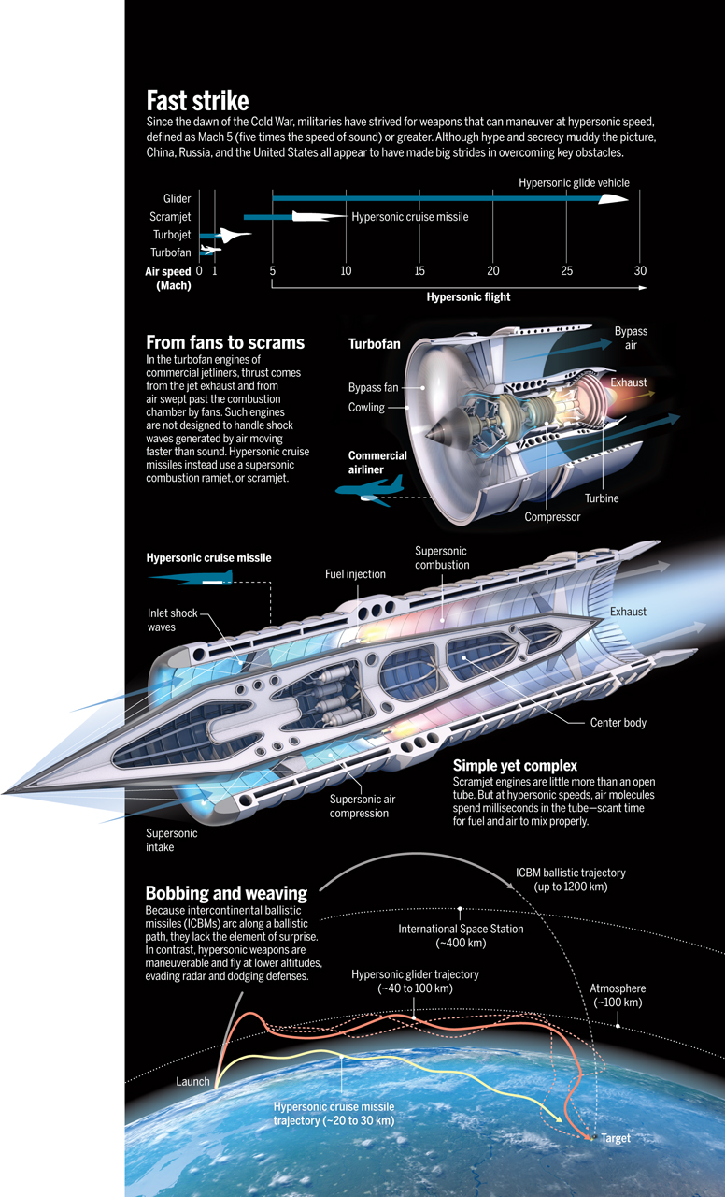https://science.sciencemag.org/content/367/6474/134/tab-figures-data

Conclusion:
A number of nations are devoting increasing attention and resources to advance research on hypersonic technology. The arrival of hypersonic weapons on the battlefield is likely to have an impact only on the tactical, not the strategic field. From the perspective of NATO member states, hypersonic weapons can produce both opportunities and challenges. On the other hand, hypersonic weapons could, if unmatched, provide an adversary with the means to coerce NATO Allies and partners in times of crisis. For these reasons, NATO Allies need to continue research and development of hypersonic technology. It would be naïve and dangerous to ignore the efforts of potential adversaries to advance this technology and introduce hypersonic missiles into their arsenals. The activities of Allies would not trigger a new arms race, but they could present an opportunity to adapt and strengthen international arms control.
Solution:
Though it is too early to have a clear picture of the security implications of hypersonic weapons, the Allies should use NATO as a forum for evaluating the challenges and opportunities that these weapons generate. On the general level, the evaluation should concentrate on the implications of hypersonic weapons for NATO’s deterrence posture and defensive architecture. On the practical level, NATO should help advance research on critical issues like propulsion systems, materials, Command and Control, and guidance systems. To that end, Allied nations should leverage their national research and activities by facilitating the exchange of intelligence, research, and design activities and by encouraging close cooperation among their national research programmes. The NATO Science and Technology Organisation could and should play a pivotal role in this process. As the research activities of numerous nations will lead to the development and possible deployment of hypersonic weapon systems, NATO Allies also need to find ways to limit the risk of proliferation. This will require both national and international measures. NATO and partner countries should examine ways to strengthen the Missile Technology Control Regime (MTCR). NATO Allies and partners should also devise measures that help to prevent the dispersion of know-how over hypersonic weapons further. This would also be in the interest of Russia, China, and the other nations that are currently developing these weapons and could be an incentive to eventually reach an agreement over an arms control treaty.

Bibliography:

https://media.defense.gov/2019/Sep/25/2002187108/-1/-1/0/59HYPERSONICWEAPONS.PDF
https://en.wikipedia.org/wiki/Hypersonic_flight
https://www.nato-pa.int/download-file?filename=/sites/default/files/2020-11/039%20STC%2020%20rev.%202%20fin%20-%20HYPERSONIC%20WEAPONS.pdf
https://fas.org/sgp/crs/weapons/IF11623.pdf
https://nationalinterest.org/blog/buzz/now-france-wants-hypersonic-missiles-2021-43202#:~:text=Project%20V%2DMaX%20

