SMYRNATO’21

Economics and Security Committee

Topic : How will NATO member states manage the economic recovery period in the aftermath of the global economic contraction due to the COVID-19 pandemic?

Esteemed Participants,

It’s our greatest pleasure and honor of welcoming you to SMYRNATO’21.

I am İlayda Bozgeyik and it is my utmost pleasure to serve as the president director of the Economics and Security Committee. My deputy director is Ceyda Şençalış and we are studying at İzmir Tevfik Fikret Science High School.

As we all know, the coronavirus that appeared in Wuhan,China in December 2019, spread to the whole world and damaged our lives.While everyone faces a risk of infection, the virus has seriously affected the economy as in all areas.

So we believe that the committee needs to work hard in order to solve the lengthen economic issues.

We believe that with the lightful of fruitful debates,outcomes of issues can be prevented.

Because of the pandemic, we will debate our topic online, therefore everyone has to make maximum effort.

Specifically and enhanced my awareness so I would like to thank President of English Alinda Ersever and her deputy Efekan Körpez for giving me this opportunity.

I am looking forward to observe and see debates in SMYRNATO. For any of inquiries please do not hesitate contact to me via email : ilaydabozgeyk@gmail.com

Key Words
Recession : a period of temporary economic decline during which trade and industrial activity are reduced, generally identified by a fall in GDP in two successive quarters.
Inflation : the decline of purchasing power of a given currency over time. A quantitative estimate of the rate at which the decline in purchasing power occurs can be reflected in the increase of an average price level of a basket of selected goods and services in an economy over some period of time.
Economic Crisis: a sharp deterioration in the economic state of the country, manifested in a significant decline in production;violation of existing production relations;bankruptcy of enterprises and rising unemployment.
Macroeconomics:the branch of economics and concerned with large-scale or general economic factors, such as interest rates and national productivity national productivity.
Extreme Poverty: living on less than $1.90 per person per day.
GDP: ‘Gross Domectic Poverty’ is the final value of the goods and services produced within the geographic boundaries of a country during a specified period of time, normally a year. GDP growth rate is an important indicator of the economic performance of a country.
Deflation : general decline in prices for goods and services, typically associated with a contraction in the supply of money and credit in the economy. During deflation the purchasing power of currency rises over time.
Microeconomics: study of individuals, households and firms’ behaviour in decision making and allocation of resources. It generally applies to markets of goods and services deals with individual and economic issues.

Introduction of The Committee
From NATO’s inception in 1955, the NATO Parliamentary Assembly has highlighted Article 2 of the North Atlantic Treaty which promotes the elimination of conflict in international economic relations and promotes economic cooperation among the Allies.For this reason, the Assembly has always placed one of its committees on its agenda to address economic issues considered by parliamentarians to be of critical importance to the community of Atlantic nations,even if they are not on NATO’s main agenda.Since coronavirus appeared and spread all over the world, the economy was also heavily affected, so all countries tried to find out how to recover after this situation. In this case, NATO included the report ‘The Economic Consequences of the COVID’19 Pandemic’ among the reports it accepted.

Introduction of The Topic
It is too soon to come to a conclusion of the current outbreak of the COVID-19 virus will exact on Western societies and the world as a whole, however initial indications are that the economic costs will be substantial and are likely to be felt for several years at least. Particularly worrying is that this infectious virus makes normal human interaction very difficult to perform and forces millions of people to stay home and go out for only the most basic reasons. This suddenly stopped all categories of human and economic activity. The global economic consequences have been significant and could be disastrous if not managed properly.

The Current Situation
COVID-19 has caused an economic shock three times worse than the 2008 financial crisis. It is essential for parliamentarians and policy makers to understand the economy underlying the pandemic, as they are tasked with formulating approaches to managing both the crisis and the aftermath. In recent years, numerous economics articles have been published trying to model the macro and microeconomic effects of pandemics. However, the aim here is neither to create a model nor to dive deeply into this important and instructive literature. Rather, it is to show the various economic forces and how they can shape the policy calculations governments are likely to make to mitigate the immediate effects of pandemics. At the same time, it will seek to protect against future pandemics in more serious ways than in the past, while determining the best ways for societies to cope with long-term costs for an unexpected pandemic that may come in the future.
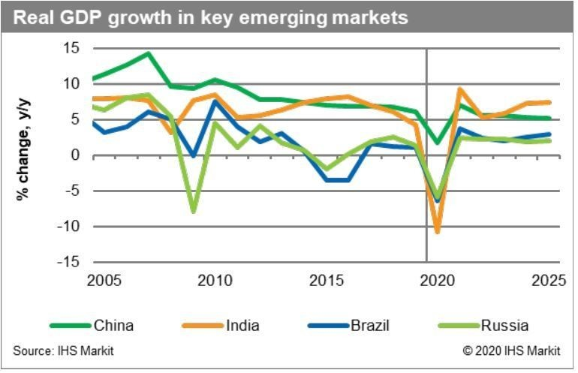

The tourism ecosystem has been hit hard by the heavy restrictions on movement and travel imposed in the wake of the Coronavirus outbreak which especially affected Italy, Spain,Turkey,Germany,UK,France,Canada and the USA.
UN Secretary-General Antonio Guterres released a new report that draws on UNWTO data to quantify the devastating impact that the coronavirus pandemic has had on global tourism. It warns that up to 120 million tourism jobs are at risk, with the economic damage likely to exceed $1 trillion in 2020 alone.

Germany
The German economy is expected to shrink for the first time since 2009, anywhere from 3 to 10 percent this year. The government itself forecasted a contraction of just over 6 percent, which would be the economy’s worst performance in decades. In March, nearly a half million German companies applied to have their employees join a short-term government work program intended to prevent mass layoffs.

European Union
EU Member States agreed on a strategy to gradually lift restrictions on non-essential
travel for residents of non-EU countries starting with a preliminary list of 14 countries.The list will be updated every two weeks and is based on a number of criteria and conditions set out in the recommendation adopted by the EU Council. Those include both epidemiological as well as economic and social considerations.

United Kingdom
The Prime Minister stated that the Government had no intention to use austerity measures in order to reduce the UK’s growing debt.Chancellor Rishi Sunak will be under pressure to outline the Government’s plans on tax when he delivers an economic update on 8 July.The chancellor is expanding a £500m fund for UK startups hit by the coronavirus crisis.

France
Comprehensive research methodology of the pre and post COVID-19 impact on the France economy.This report also includes a detailed and extensive market overview with key analyst insights.An exhaustive analysis of macro and micro factors influencing the market guided by key recommendations.Analysis of regional regulations and other government policies impacting the France economy.Insights about market determinants which are stimulating France economy.Detailed and extensive market segments with regional distribution of forecasted revenues.Extensive profiles and recent developments of market players.

Italy
Italy’s GDP volume contracted by close to 17% y-o-y in the second quarter.In the second half of the year there is room for a ‘technical’ recovery, but we believe the economy will not have fully recovered before 2025.We project the economy to contract by 11.5% this year and to grow by 7% next year.We do not expect an outright banking crisis, but bank balance sheets will deteriorate and the overall picture remains rather gloomy.Government finances are set to deteriorate significantly.Government bond yields are close to historic lows, but this is mainly due to ECB support.Early elections are unlikely for now. But as things stand, the probability that the next elections, whether early or in 2023 as planned, deliver a far-right eurosceptic government is large.

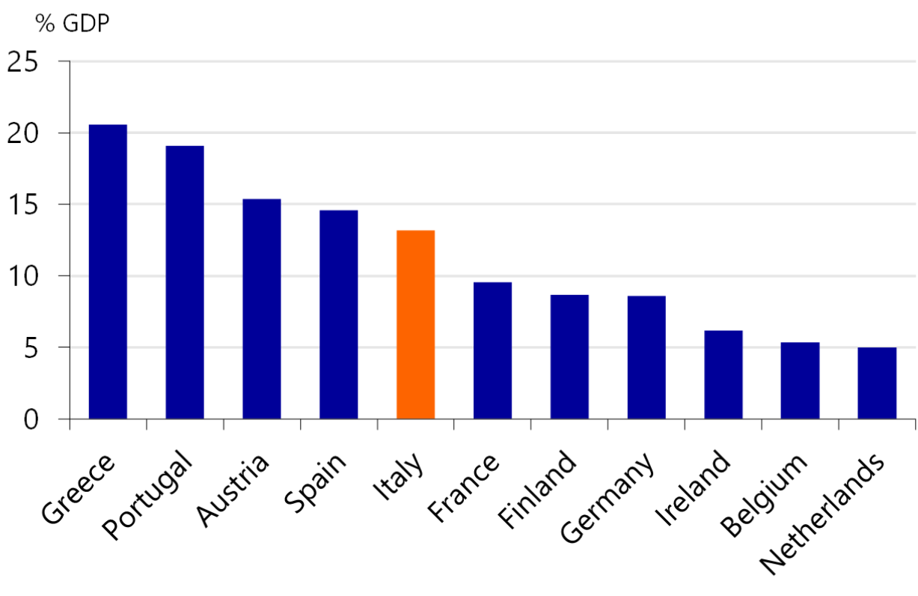

Containment measures are being lifted, paving the way for a ‘technical’ recovery

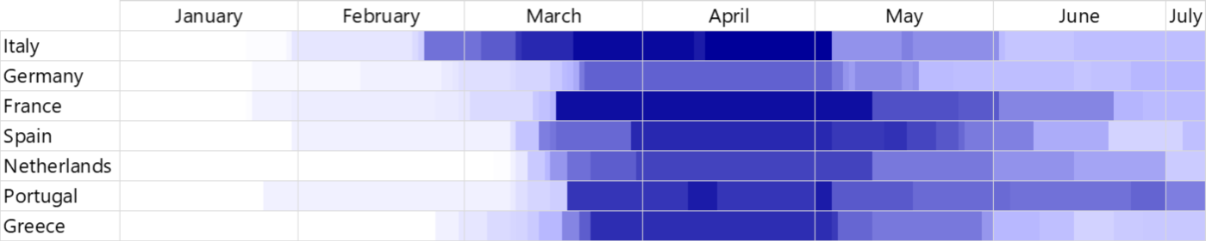

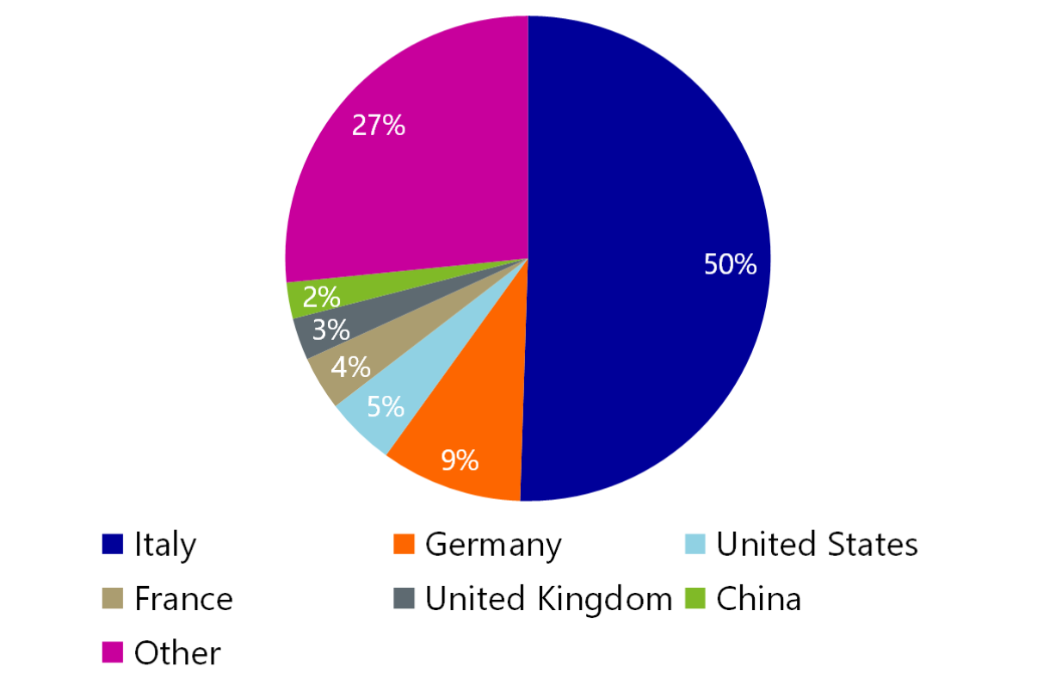
Half of the people arriving at tourist accommodations is foreign

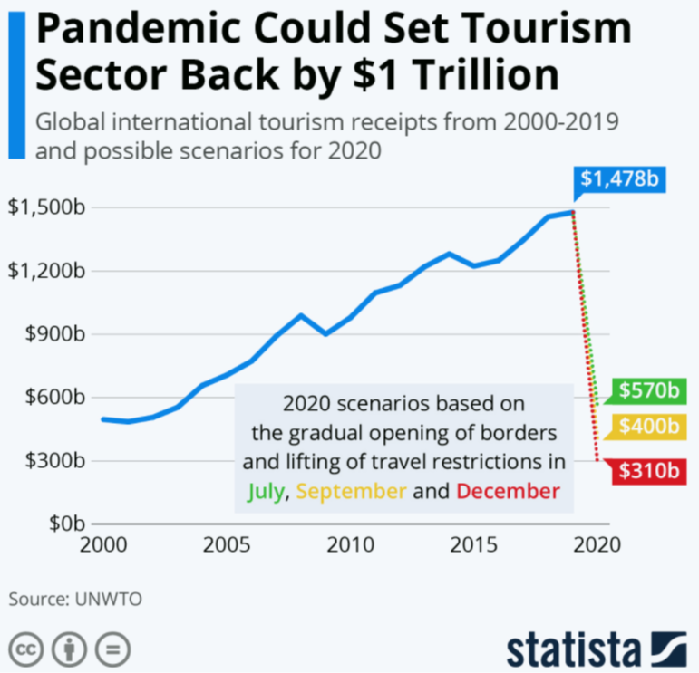
Tourism is important for countries’ economy

History of Topic
The global community is currently experiencing its most significant pandemic since the outbreak of the Spanish flu in 1918-19. But pandemics are not as rare as many people think. Indeed, in the last 120 years, there have been four major pandemics in which influenza viruses have mutated genetically, and emerging new viruses surpass humanity's natural defenses: 1918, 1957, 1968, and 2009. However, the lethality of these diseases has changed significantly. For example, the so-called swine flu in 2009 proved mild in its health impacts, unlike the flu in 1918, but it spread widely and rapidly due to the high rate of global integration and dense global travel networks.
Past Actions

Since the outbreak of the coronavirus, most countries have taken some restrictions and measures to fix their damaged economies. While Europe and emerging markets have been hit hard economically, China has escaped a recession.As restrictions on society and businesses ease across much of Europe and the Middle East, a new group of public policy challenges have materialized as Governments balance public health concerns with restarting economies as quickly as possible. Finding this balance is crucial, and results in unprecedented and far-reaching, financial, welfare and regulatory initiatives emerging daily across countries and regions. Most countries have stated economic recovery plans for this issue.

Solutions
In the latest event in the Berkeley Conversations: COVID-19 series, some of the nation’s leading economists and policy experts said the effort will require expansive additional measures to relieve workers, state governments and businesses. And they agreed that the
recovery program must focus on workers and communities of color who are bearing the brunt of the crisis.

The recovery program likely will cost trillions of dollars, on top of relief measures already approved by Congress and President Donald Trump. But, they said, aggressive investment and well-designed policy could bring the economy back more quickly and with less long-term distress for workers and businesses. They concluded that the nation can afford the investment.

Some lawmakers have suggested that the United States must move as quickly as possible to return to normalcy and restart the economy. But the Berkeley experts suggested pitting public health against the economy is a false choice. Rather, they said, the two are inseparable: Assuring public health is the first step toward a sustainable recovery.

Conclusion

In conclusion as an Economic and Security Committee we should discuss issues that we have stated. Firstly, we expect you to search your country’s current situation,what your countries have stated which restrictions and solutions for these issues.In the other hand you should search your country’s policy. Based on these informations and graphics,you
should think on what your countries and other countries should do after these issues.

Important Points to Consider
-The pandemic is taking a heavy human and economic toll on the poorest countries. While the developed countries play a more active role in combating the pandemic due to income inequality, the threat of vaccines or drugs that will enable people to return to normal after the crisis disappears, further increasing poverty in some countries due to economic factors.
- Although COVID-19 seem like a health crisis, it has also turned into a global economic crisis in terms of its effects
-According to World Bank forecasts, the global economy will shrink by 5.2% this year. That would represent the deepest recession since the Second World War.

-Due to reports, 34.3 million people are estimated to fall below the extreme poverty line in 2020 due to coronavirus, adding more than half of this is occurring in African countries.

- China’s economy expanded by 2.3% in 2020, roaring back from a historic contraction in the early months of the year to become the only major world economy to grow in what was a pandemic-ravaged year in Asia.
-Tourism and tourist departure and arrival affect the country’s money inflow and outflow.
-Modeling by the World Bank suggests that in some regions a full recovery will not be achieved until 2025 or beyond.

Links to research

https://www.weforum.org/agenda/2020/09/an-economist-explains-what-covid-19-has-done-to-the-global-economy/
https://www.lovemoney.com/gallerylist/96612/how-coronavirus-has-affected-the-worlds-economies
https://instinctif.com/insights/covid-19-government-recovery-plans-9/
https://assets.kpmg/content/dam/kpmg/ie/pdf/2020/09/ie-Job-Support-Scheme-NI_September-2020.pdf
https://www.gov.bm/articles/covid-19-fiscal-and-economic-plan-update
https://www.nato-pa.int/download-file?filename=sites/default/files/2020-06/094%20ESC%2020%20E%20-%20THE%20ECONOMIC%20CONSEQUENCES%20OF%20THE%20COVID-19%20PANDEMIC_1.pdf
https://cdn.istanbul.edu.tr/file/JTA6CLJ8T5/0D670FC8CDB24397A4A997448B5CEE75
https://www.consilium.europa.eu/et/documents-publications/library/library-blog/posts/think-tanks-reports-on-covid-19-and-the-recovery-fund/#
https://www2.deloitte.com/us/en/insights/economy/covid-19/economic-impact-covid-19.html/
https://www.domo.com/covid19/economy/

