COMMITTEE: Political Committee
SUBJECT: What should be NATO's political strategy for significant threats to its security such as wars, attacks, conflicts and growing international rivalry within and outside its borders?
BOARD MEMBER: Efekan Körpez
RANK: Vice President of the General Assembly
Political Committee
The Political Committee (PC) focuses on all political questions concerning the security of NATO and its member and partner countries.
Introduction
As a major political and military actor on the global stage, NATO abides by a strategy combining military and political means to safeguard its members’ interests and security while being committed to its essential principles of individual liberty, democracy, human rights and the rule of law. The NATO Strategic Concept, adopted in 2010, designates three core tasks for the alliance: collective defence, crisis management and cooperative security. Resolutions to conflicts that have the possibility to affect the members of the alliance fall under the task of crisis management, in which the priority is given to political solutions including diplomatic dialogue. However, military tools may be employed should political means fail to bear fruit.
Definitions of key words
Collective defence
NATO members are bound by the Article 5 of the North Atlantic Treaty to always assist each other against attacks. NATO deters and defends against any threat of aggression, and against emerging security challenges where they threaten the fundamental security of individual Allies or the Alliance as a whole.
Crisis management
NATO has a robust set of political and military capabilities to address the full spectrum of crises – before, during and after conflicts. NATO will actively employ an appropriate mix of those political and military tools to help manage developing crises that have the potential to affect Alliance security, before they escalate into conflicts; to stop ongoing conflicts where they affect Alliance security; and to help consolidate stability in post-conflict situations where that contributes to Euro-Atlantic security.
Cooperative security
The Alliance is affected by, and can affect, political and security developments beyond its borders. The Alliance engages actively to enhance international security, through partnership with relevant countries and other international organisations; by contributing actively to arms control, non-proliferation and disarmament; and by keeping the door to membership in the Alliance open to all European democracies that meet NATO’s standards.
Political agenda
A political agenda is a list of subjects or problems to which officials of a government or an organization as well as individuals outside the body are paying serious attention at any given time.
NATO’s crisis management from past to present
The very formation of NATO traces its roots back to a major political rivalry between the United States and the Soviet Union. In fear of Soviet aggression, on April 4, 1949, the 12 founding members of NATO on both sides of the Atlantic signed the North Atlantic Treaty, providing the legal basis of the alliance we know today. The persistent threat of Soviet aggression lead to increased military and political cooperation between member states during the Cold War. However, despite the hostility between the USSR and NATO, there was no military confrontation between the two sides during the entirety of the Cold War, proving the alliance’s effectiveness at deterring Soviet aggression. Instead, the alliance kept expanding by adding new members in Europe and promoting its core values of individual liberty, democracy, human rights and the rule of law, further halting Soviet expansion both territorially and ideologically.
After the end of the Cold War, there were great changes in the international security environment and thus came NATO’s first military interventions in numerous places including Kuwait and Yugoslavia. As these places right on NATO’s doorstep were struggling with internal conflicts resulting in regional destabilization and civilian suffering, affecting both the conflict areas and the alliance members neighboring them, NATO took the decision to militarily intervene in these regions in order to ensure permanent peace. However, political dialogue has always been prioritized in terms of crisis management, with military tools being a last resort. This policy continues today.
Article 5 of the North Atlantic Treaty, which forms the basis of the aforementioned task of collective defence stipulating that all NATO members will respond to an attack on a member state, was invoked on September 12, 2001, right after the 9/11 attacks in the United States which were perpetrated by Al-Qaeda, a terrorist organization which had been thriving in Afghanistan as it used to be a safe haven for terrorists. Over the next decade NATO fought against various terrorist groups in Afghanistan, endeavouring to clear it of terrorists and help the installment of a stable, democratic government in Afghanistan. The employment of military tools in Afghanistan is now largely over and NATO is now committed to political resolutions of the country’s internal issues while providing training for Afghan forces. NATO similarly intervened in Libya in 2011.
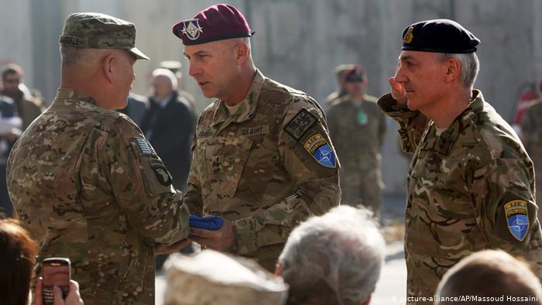
Image 1: Photo of NATO troops stationed in Afghanistan. Source: Associated Press via Deutsche Welle
However, NATO does not militarily intervene in every conflict somehow affecting member states. An example is the second Nagorno-Karabakh War in 2020 between Armenia and Azerbaijan, both partners of NATO, with NATO member Turkey openly supporting Azerbaijan. NATO General-Secretary stated that NATO was not a part of the conflict, wishing hostilities and casualties to cease.
As said before, NATO always prioritizes political and diplomatic tools to resolve conflicts. This becomes especially apparent when tensions between NATO member states arise, such as the recent tensions over maritime boundaries between Greece and Turkey to which the General-Secretary reacted by saying that the alliance was ready to ease tensions between the two sides and support the diplomatic mediation efforts by Germany.
The recent NATO 2030 initiative calls for an update of the 2010 Strategic Concept, as many of the present-day security issues including the escalation of tensions with Russia and the growing rivalry with China did not constitute major issues at that time. Both the Strategic Concept and the NATO 2030 initiative calls for the use of non-military political means to prevent and resolve crises, and to manage post-crisis situations. The initiative also calls for political unity, cohesion and improved collaboration between member states of the alliance, swifter response times to crises, upholding and strengthening NATO’s core values and key tasks as mentioned in the Strategic Concept, strengthening the role of civilian and political bodies within the alliance, improved data and intelligence sharing between member states, strengthened partnerships with non-member states and a common NATO-wide policy for influential external powers including Russia and China.
As outlined by the NATO 2030 initiative, NATO must adapt its non-military agenda to an ever-changing global security environment.
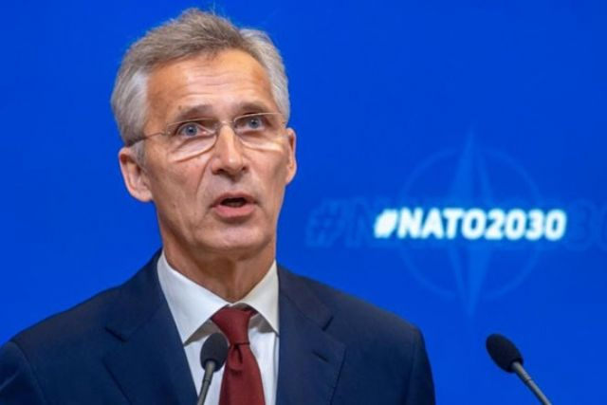
Image 2: Current NATO Secretary-General Jens Stoltenberg introducing the NATO 2030 initiative. Source: Timeturk
Current and recent developments
Internal conflict in Afghanistan
After many years of military involvement, NATO is now engaged in a non-combat mission in Afghanistan, named Resolute Support, providing training, advice and assistance to Afghan security forces and institutions. Key functions of the mission include supporting planning, programming and budgeting; assuring transparency, accountability and oversight; supporting the adherence to the principles of rule of law and good governance; supporting the establishment and sustainment of processes such as force generation, recruiting, training, managing and development of personnel.
Post-conflict situation in Kosovo
After years of conflict -which saw NATO intervention- and unrest, Kosovo unilaterally declared independence in 2008. Since the unilateral declaration of independence, NATO has helped to create a professional and multi-ethnic Kosovo Security Force, which is a lightly armed force responsible for security tasks that are not appropriate for the police. Meanwhile, NATO strongly supports the European Union-sponsored Dialogue between Belgrade and Pristina. The normalisation of relations between Serbia and Kosovo is seen by NATO as key to solving the political deadlock over northern Kosovo.
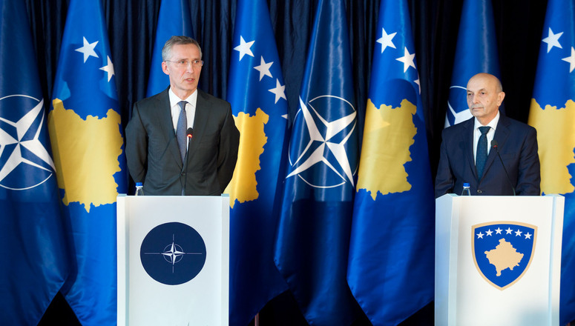
Image 3: Secretary-General Stoltenberg with former Kosovar Prime Minister Isa Mustafa. Source: NATO
Maritime dispute between Turkey and Greece
A long-standing dispute over maritime boundaries between Turkey, Greece and Cyprus resulted in escalated diplomatic and military tensions between Turkey and Greece in 2020. NATO has repeatedly called for the easing of tensions and the diplomatic resolution of the dispute through mediation.
Second Nagorno-Karabakh War
Clashes over the disputed region of Nagorno-Karabakh escalated in September 2020 and resulted in a full-scale war between Azerbaijan and Armenia -both of which are NATO partner states- with Turkey, a prominent NATO member openly supporting Azerbaijan. NATO stated that it was not a part of the conflict and called for the cease of hostilities and civilian atrocities. The war later ended through Russian diplomatic mediation efforts.
Hostilities with Russia
Tensions between Russia and NATO reached its peak after Russia, in defiance of international law, invaded the Ukrainian territory of Crimea and annexed it. Since then, there has been a tremendous increase in Russian activities targeting NATO, including cyberattacks and militarization in Russian territories bordering NATO member states. NATO’s response has been military and non-military based on deterrence and readiness, with strengthening the alliance’s military presence near the Russian border and embracing sanctions against the country. Due to Russia’s uncompromising aggression, the diplomatic channel between NATO and Russia largely remains inactive.
Growing rivalry with China
China’s growing political, military and economic influence has been regarded as presenting both opportunities and challenges by NATO. From an ideological standpoint, China embraces values that are largely opposed to that of NATO, with an authoritarian, anti-democratic worldview. In light of all the recent developments with regards to China, China should no longer be seen as merely an economic and regional competitor, but rather a full-scale global rival, similar to the Soviet Union during its existence. China does not pose an imminent security threat to the alliance, but its massive military capabilities and its desire to spread its worldview, military and economic might constitute a significant threat to the alliance’s interests. Proposed precautions to safeguard the alliance’s interests include an alliance-wide cooperation and strategy with regard to China, devoting more political resources to the growing threat, improving its capability of anticipating and reacting to potential threats which may be posed by China in the future and the continuation of political dialogue with China on shared interests as well as differences.
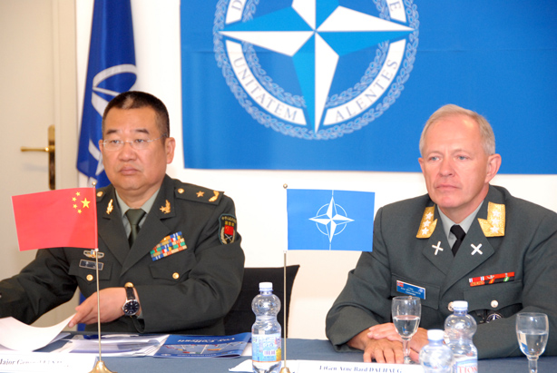
Image 4: Meeting between the Chinese delegation and the NATO delegation in 2012. Source: NATO
Hybrid and cyber threats
So-called ‘hybrid’ methods, such as propaganda, deception, sabotage, and other non-military tactics have been used throughout the history of warfare to undermine adversaries from within. Hybrid and cyber attacks are not, themselves, threats; they are tools employed by hostile actors, state, and non-state actors alike, that are the threat. These methods are especially targeted at the Allied nations with a specific vulnerability. In recent years, NATO has done more to counter these threats, establishing bodies within the alliance specifically tasked with countering hybrid and cyber threats. An improved handling of these threats should include developing an alliance-wide comprehensive framework dealing with these threats, better informing the general public, developing and funding new cyber-defence mechanisms and employing political tools to counter these threats. Political tools include diplomatic de-escalation efforts through high-level visits, statements, public press conferences, issue-specific consultation between NATO member states and policies aimed at political deterrence.
Official documents on the matter
The documents of 2010 Strategic Concept and the NATO 2030 initiative provide detailed information about NATO’s policies on the matter. It is highly recommended that delegates inform themselves about the official NATO policy by reading these documents on NATO’s official website. The links to the documents are given in the “Useful Links” section.
Conclusion
As a major player on the world stage, NATO will continue to be affected by numerous threats in different ways. The core tasks of NATO, as outlined by the 2010 Strategic Concept, namely collective defence, crisis management and cooperative security, are key at countering threats. However, in a contemporary global environment where the balance of power keeps changing and new non-conventional security threats keep emerging, NATO needs to be swifter in appropriately responding to imminent and potential security threats. As has been the general principle for many years, political responses and solutions should always be prioritized, with military solutions being reserved as a last resort in case political efforts fail to succeed. All threats require closer and more integrated cooperation and collaboration between all member states as well as political unity through a common political agenda.
Conflicts
The 21st clause of the 2010 Strategic Concept outlines the general strategy which should be pursued with regard to conflicts: “The lessons learned from NATO operations, in particular in Afghanistan and the Western Balkans, make it clear that a comprehensive political, civilian and military approach is necessary for effective crisis management. The Alliance will engage actively with other international actors before, during and after crises to encourage collaborative analysis, planning and conduct of activities on the ground, in order to maximise coherence and effectiveness of the overall international effort.”
As stipulated by following clauses, the best way to handle a conflict is to prevent it from happening. NATO should take up a more influential role as a diplomatic mediator. Funding political establishments and political research, especially analyzing the causes of unrest, combined with international aid aimed at alleviating the unrest may be essential to prevent unrest from turning into a conflict.
With regard to internal conflict within the alliance, NATO should always remain neutral and promote easing of tensions through political and diplomatic means. This should apply for disputes between member states and upheaval in a particular member state.
Russia
NATO should continue to exert pressure on Russia about its illegal occupations, political and military hostility and its use of non-conventional warfare against NATO member states. Sanctions against Russia should continue and even be strengthened until Russia begins to compromise and follow international law in a genuine way. However, the largely inactive diplomatic channels should become more active and dialogue aimed at mutual understanding and peace should never be suspended. NATO should strengthen its political and diplomatic relations with partner countries affected by or has the potential to be affected by Russian aggression.
China
The current threats posed by China are not military ones, but rather political and economical ones. As a regime with authoritarian values in direct contrast with NATO’s democratic values aimed at ensuring liberty and the rule of law, NATO should proactively engage in spreading its value throughout the globe through bilateral cooperation, especially in countries where Chinese infiltration and influence are a serious issue. NATO should promote economic independence from China within the alliance as the economic influence of China paves the way for further political infiltration. Political cooperation with China should take place when the two parties have common interests, while dialogue and diplomatic efforts should be employed when the two parties are at odds with each other.
Hybrid and cyber warfare
This type of novel warfare does not require the use of military force and political tools are at the forefront of countering hybrid warfare. As aforementioned, political tools include diplomatic de-escalation efforts through high-level visits, statements, public press conferences, issue-specific consultation between NATO member states and policies aimed at political deterrence. More funding needs to be allocated to organizations under the roof of NATO dealing with hybrid warfare and as well as to research.
A previous study guide from our 2018 conference contains a very detailed, comprehensive outlook on hybrid warfare and potential solutions. Delegates who wish to inform themselves more about the matter are recommended to take a look at it. The link to the former study guide is given in the “Useful Links” section.
Notice
Many parts of this study guide has been directly taken without alteration from relevant official documents published by NATO.
Useful links
2010 Strategic Concept (in English), at https://www.nato.int/nato_static_fl2014/assets/pdf/pdf_publications/20120214_strategic-concept-2010-eng.pdf
2010 Strategic Concept (in Turkish), at https://www.nato.int/nato_static_fl2014/assets/pdf/pdf_publications/20120207_strategic-concept-2010-tur.pdf
NATO 2030 Initiative, at https://www.nato.int/nato_static_fl2014/assets/pdf/2020/12/pdf/201201-Reflection-Group-Final-Report-Uni.pdf
IzmirNATO 2018 Committee of Civil Dimension of Security Study Guide on Counteracting Russian Hybrid Warfare, at https://pdfhost.io/v/obeox2iGC_2018_CDS_Russian_Hybrid_Warfarepdf.pdf
References
Wikipedia, at https://en.wikipedia.org
NATO, at https://www.nato.int
TRT World, at https://www.trtworld.com
Deutsche Welle, at https://www.dw.com
Anadolu Agency, at https://www.aa.com.tr

