COMMITTEE: CIVIL DIMENSION OF SECURITY (CDS)
SUBJECT: How can racial and gender inequalities with regard to security and defence be resolved?

CIVIL DIMENSION OF SECURITY
The Civil Dimension of Security was first established as the cultural committee in 1956. In this committee we focus on the responsibilities, protection and welfare of civilians. Also the areas covered by the committee include:
*Democracy
*Civil liberties
*Fundamental freedoms
*Human rights
*The protection of minorities.

INTRODUCTION
Nato is an equal opportunities employer commited to valuing everyone as an individual. relative to men (across racial groups) and white women, Black and latina women often have less desirable jobs and lower earnings. Especially in the United States, economic inequality is both racialized and gendered. A growing number of studies have identified several factors that have influenced the size of the racial gap, which has been found to vary by social class status and gender as well. From 2014 low-income African American Women in a project, we explore relationships between social stressors (racial and gender discrimination) and individual stressors occurring in each of six distinct social contexts. Such as social network loss, motherhood, employment and finances, personal injury and accidents, adult victimization and child victimization.

RACIAL AND GENDER INEQUALITIES
Women earn less than men, and racial and ethnic minorities earn less than comparably skilled white workers. At the bottom rung of these inequalities are women of color. Minority women have the lowest income and earnings, usually working in the lowest paid occupations and industries and are consequently disproportionately in poverty. Both the separate and the intersectional effects of gender and race are estimated for African American, Latina, and Asian women’s earnings in the US over five decades. In addition, the effect of state minimum wage laws and laws that prohibit affirmative action is also estimated regarding their effects by gender, race, and the intersection.
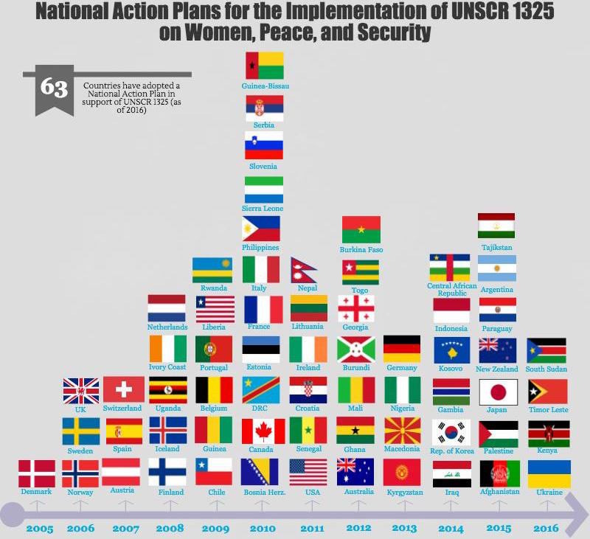
What Are National Action Plans and Why Do They Matter?

For peace to be sustainable, women must be fully engaged in building it. The power of inclusivity in peace processes is undeniable, yet norms about who prevents and resolves conflict or builds stability have been slow to change. Recognizing this, the UN Security Council adopted Resolution 1325 in 2000. It calls upon member states to increase women’s participation in maintaining peace and security.
The Resolution alone, however, wasn’t enough to inspire immediate action. Understanding the urgency of the matter, in 2005 the Security Council asked individual countries to develop their own vehicles for implementation: national action plans or NAPs.
NAPs are one of the most powerful tools governments, multilateral organizations, and civil society have to increase the inclusion of women in politics and peacebuilding, and the protection of women and girls in times of war.
NAPS provide a structure – a sequence of actions – to achieve the goals outlined in Resolution 1325. They:
1)Help implementers set priorities, coordinate actions, simplify decision-making, and track progress;
2)Prompt meaningful changes in behavior, policies and funding;
3)Provide civil society a mechanism through which they can hold governments accountable; and
4)Create space for governments, multilateral institutions, and civil society to work together and accomplish more.
NAPs provide a blueprint that governments, multilateral institutions, and civil society can use to coordinate action and track results.
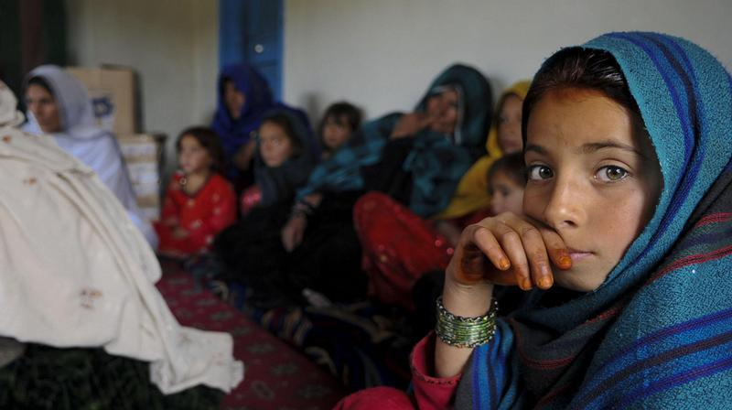
AFGHANISTAN AND SEXUAL AND GENDER BASED VIOLENCE.
The Afghan authorities have achieved considerable progress with respect to sexual and gender based violence. In 2015, Afghan government a adopted seven year National Action Plan for the Implementation of UNSCR 1325 setting out conceret objectives relating to the protection of women from all types of violence and discrimination. In particular, the plan calls for the elimination of the prevailing culture of impunity surrounding sexual violence. In 2017, the Afghan authorities enacted a new law on human trafficking m, criminalizing the practice of bacha bazi, referring to the sexual abuse of children often bought or kidnapped from impoverished families(UNICEF 2018)

Women and girls remain exposed to the violence in the country. Eighty-seven per cent of the over fifteen million Afghan women have experienced some form of violence in their lives. Even when they have not been forced to relocate, women and girls remain especially affected by gender inequality, persistent instability, chronic discrimination and inadequate access to services.
IMPLICATIONS OF COVID 19 FOR THE PREVENTION OF AND RESPONSE TO CONFLICT-RELATED SEXUAL VIOLENCE
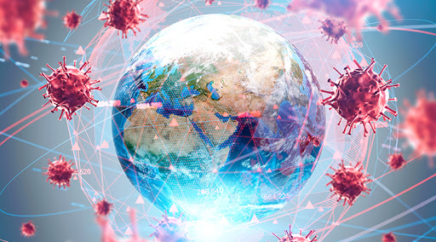
The potential spread of COVID-19 in refugee and IDP settings may exacerbate the already high risk of sexual violence in such situations, including increased intimate partner violence, potential of trafficking, forced prostitution and sexual exploitation as quarantine and other physical distancing measures impact. The imposition of quarantines, curfews and other restrictions on movement to abate the spread of COVID-19, are already hampering the possibility for survivors to report sexual violence, further exacerbating the existing structural, institutional and sociocultural barriers to seeking redress for such crimes. Quarantines and other restrictions on movement have also begun to disrupt the monitoring, reporting and outreach work of United Nations entities mandated to gather information, verify violations and enhance compliance by both State and non-State parties with international obligations, including relevant Security Council resolutions.
In addition, some existing shelters and safe spaces have either been closed temporarily or are being repurposed for the COVID-19 response. Quarantines, curfews, school closures and other restrictions on movement are having a detrimental impact on the ability of survivors to physically access services even where they do exist. In this regard special consideration needs to be given to refugee and internally displaced communities, a disproportionately large percentage being women and children, for whom the challenges of availability and accessibility of services are exacerbated by circumstances of their displacement. Fear of contracting COVID-19 further exacerbates the challenge of service provision. Health service providers, emergency first responders and women’s civil society organizations are often the first point of contact for survivors of sexual violence. Yet, women including survivors of sexual violence may be less willing to seek help, particularly for health care, because of perceived risks of contracting COVID-19, for fear of infection and the potential for transmitting the virus to their families.
Ultimately, it is essential to sustain focus on the scourge of conflict-related sexual violence throughout the COVID-19 pandemic, so that in the long term, the normative, institutional and operational gains in the prevention of and response to CRSV are not reversed. The Office of the Special Representative on Sexual Violence in Conflict will continue to gather information and evidence from the field on the impact of COVID-19 on preventive action and response programming, as well as mitigation and response measures that are being put in place by United Nations country presence and civil society partners. An empirically grounded, field-based analysis will be essential to inform policy and operations at this unprecedented moment.

AFGHAN WOMEN’S VIEWS ON VIOLENT EXTREMISM AND ASPIRATIONS TO A PEACEMAKING ROLE 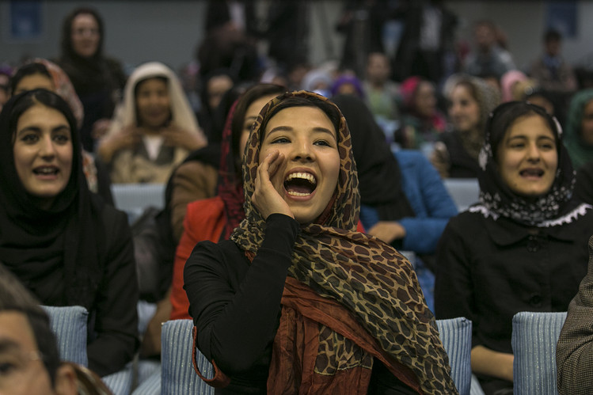
Participation in violence and, conversely, efforts at peacebuilding in Afghanistan remain dominated by men. Understanding the role of Afghan women in violent extremism and peacemaking today requires reckoning with the polarization between the increasing number of liberal initiatives and the long-standing conservativism in Afghan society, which has traditionally restricted women’s activities to the domestic sphere. Between these two poles, however, lies a more nuanced, and growing, space where women actively contribute to Afghan society beyond the immediate confines of the home or small community. To better understand the changing roles of Afghan women today and their contributions to peacebuilding or violent extremism, interviews were conducted with 350 respondents (more than 90 percent women), comprising a mix of urban and rural residents in seven provinces. Respondents were queried about activism in their communities, in particular in relation to peacemaking and countering violent extremism; their understanding of and involvement in extremism or violent extremism; their most frequent means of accessing information; and awareness of and participation in organized groups active in their areas.
From the Taliban-imposed restrictions to private space the country has moved to a stage where women in Kabul and the provinces are harnessing, to varying degrees, newly available opportunities in the domestic and even international political arena. This rise began when several women were appointed to high offices in the post-Taliban government—the Interim Administration of 2001–2, which featured a female vice chairperson, Sima Samar, and a female minister of public health, Sohaila Sediq. There were 160 female delegates at the Emergency Loya Jirga that approved the Transitional Authority in 2002. The leadership of the Transitional Authority was up for election in the Loya Jirga, and Hamid Karzai was challenged by Masooda Jalal, who had served as an aid worker before 2001 (and would serve as minister of women’s affairs in Karzai’s presidential cabinet from 2004 to 2006). She received 171 of the 1,555 participant votes. Women commissioners also played a notable role in the drafting of the country’s current constitution, adopted in 2004, which guaranteed women a minimum of 25 percent of seats in parliament. The foundations laid in these years created space for an increased role for women in the country’s present and future, as is widely acknowledged.

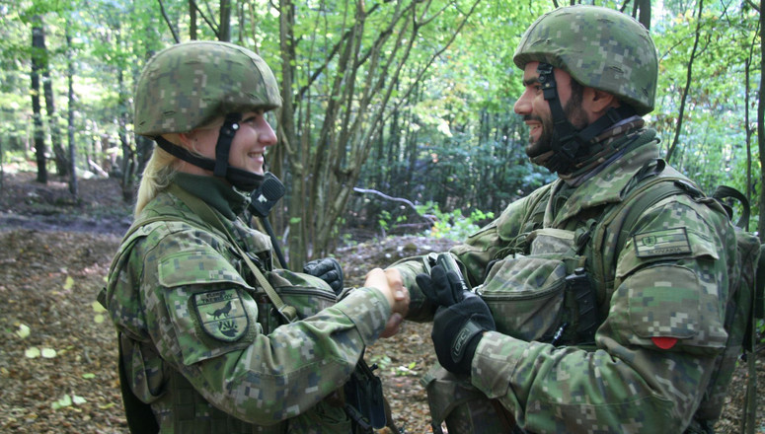
NATO’S EXPERIENCE
Preventing violence against women and protecting those who most in need is deeply rooted in NATOS core values of respect for human rights and rule of law. NATO has developed a robust normative framework to prevent CRSV and protect civilians from violence. In 2015, NATO adopted Military Guidelines on the prevention of, and response to, Sexual and gender based violence that guide the actions of its forces in operations
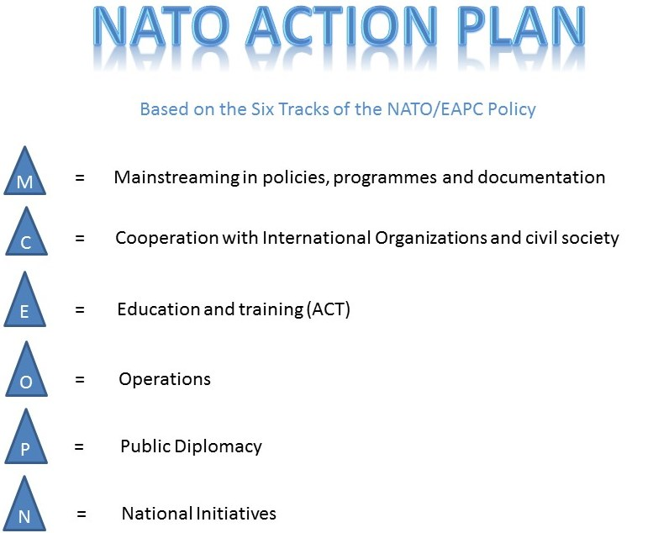
NATO also supports Allies and key partners in their efforts to combat CRSV. It works closely with local authorities in member states and partner nations that deliver education and training to their national armed forces personnel on gender equality. These trainings help increase awareness among national forces on the importance of integrating gender perspectives in military operations, including on topics related to sexual violence.

